**Name: Aryaman Mishra**

**Reg. no: 19BCE1027**

**Date: 23-08-2021**

**EXPERIMENT NO: 4**

**Design and Troubleshooting of Bridge Rectifiers with RC filters**

**Aim:** Design Half wave rectifier and plot input voltage and output voltages

**Software used:** LTSpice

**Components required:** Resistors, voltage source, inductors, diode.

**Task 1.1:** In phase windings (2m:1m)

**Circuit:**

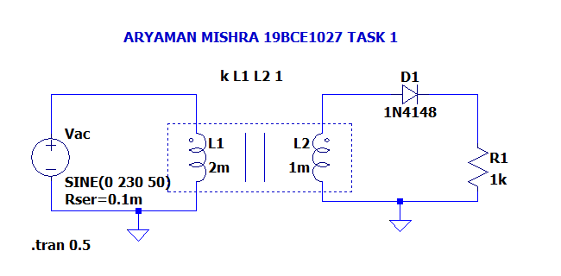

**Output:**

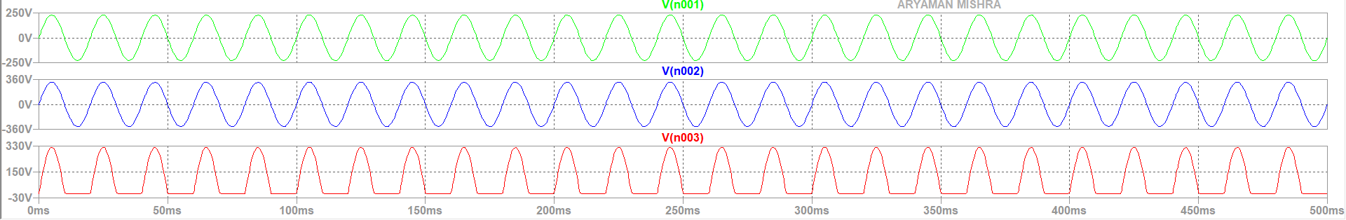

**Task 1.2:** In phase windings (1m:1m)

**Circuit:**

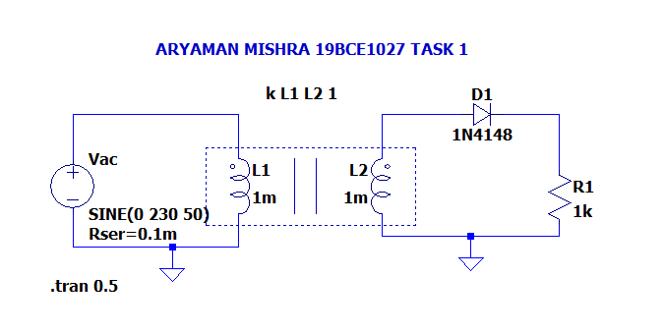

**Output:**

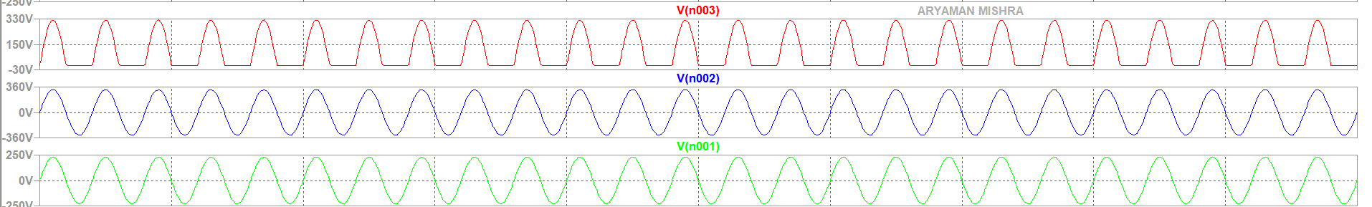

**Task 1.3:** n phase windings (1m:2m)

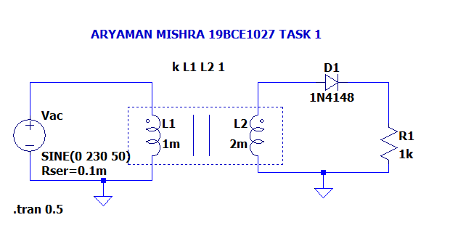

**Output:**

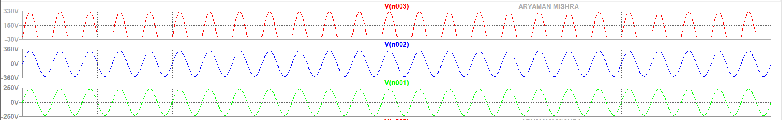

**Task 1.4:** 180° out of phase windings (2m:1m) 1.5

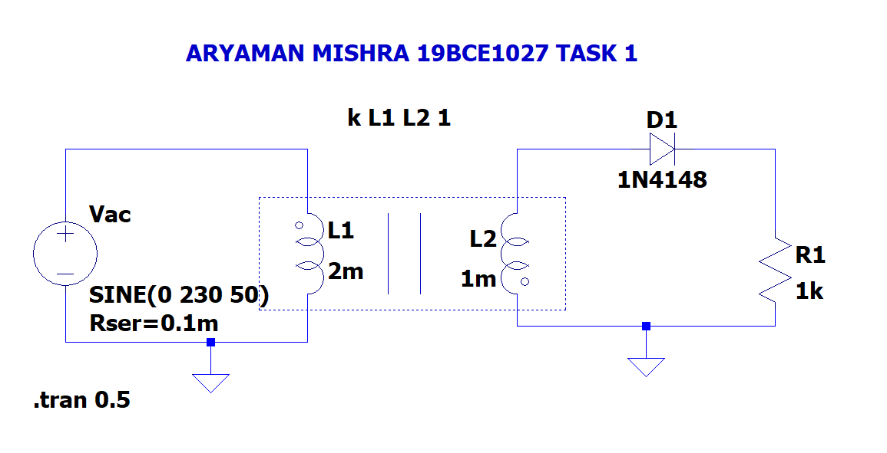

**Output:**

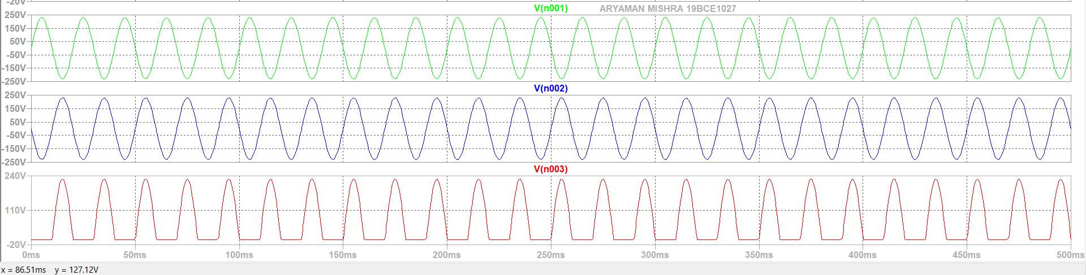

**Task 1.5:** 180° out of phase windings (1m:1m) 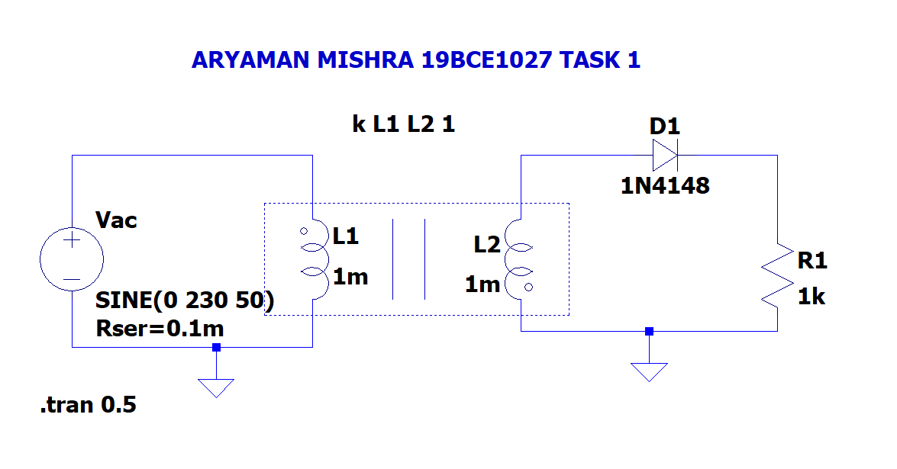

**Output:**



**Task#02: Full wave rectifier Design**

Full wave rectifier and plot input voltage and output voltages : (across the load – resistor) with

**2.1 In phase windings (1m:1m)**

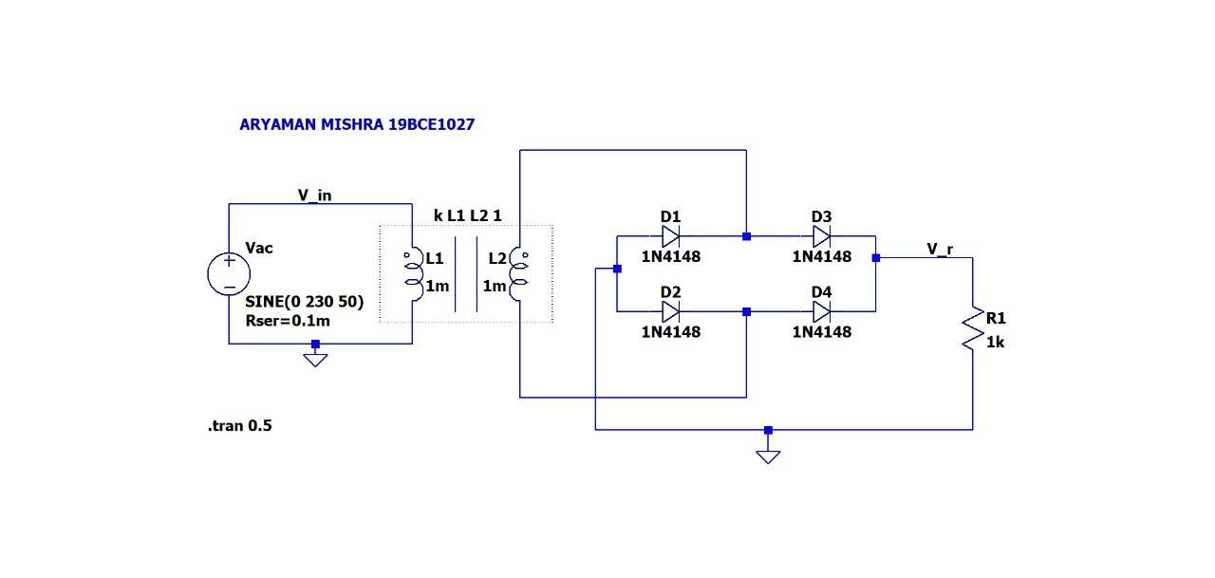

**Output:**

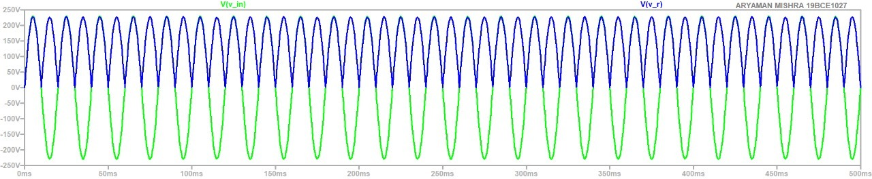

**2.2 180° out of phase windings (1m:1m)**

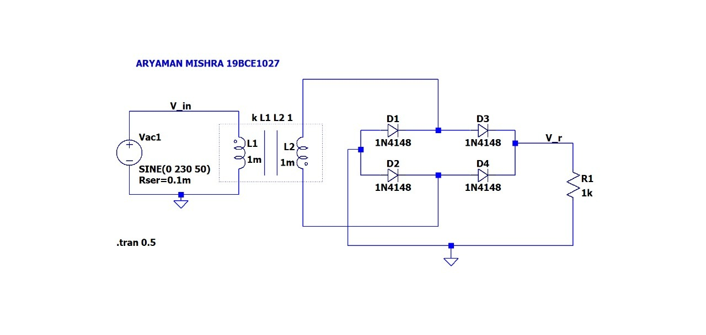

**Output:**

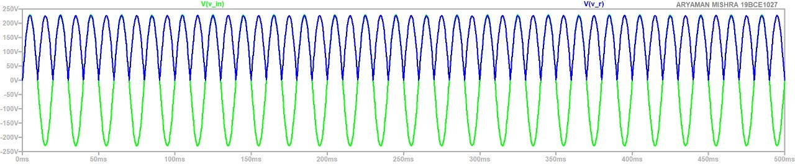

**Task#03: DC Power supply**

**Obtain output voltage plot for the tasks**

**3.1 to 3.4 given in table below and enter observation**

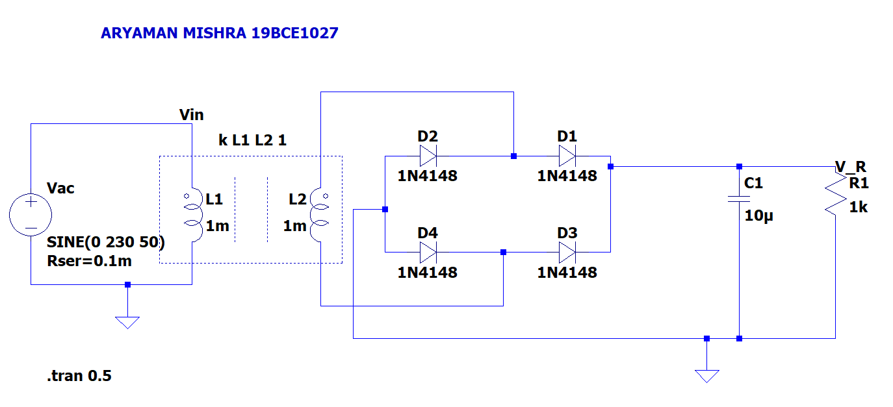

**10uf = 122.498V, 226.589V**

**1m = 223.709V, 225.405V**

**100uf = 209.498 V, 227.85 V**

**10m = 224.23V, 224.23V**

|  |  |  |  |  |
| --- | --- | --- | --- | --- |
| **Task** | **Capacitor** | **Comment on charging** | **Comment on discharging** | **Comment on attainment of 100% of peak of input and saturation (constant) of output.** |
| **3.1** | **10uF** | **Increased voltage** | **Decreased voltage** | **No voltage gets passed** |
| **3.2** | **100uF** | **Increased voltage** | **Decreased voltage** | **No voltage gets passed** |
| **3.3** | **1mF** | **Voltage remains same** | **Voltage remains same** | **No voltage gets passed** |
| **3.4** | **10mF** | **Voltage remains same** | **Voltage remains same** | **No voltage gets passed** |

**Conclusion:We designed and simulated the clippers and clampers circuits using LTspice tool. Thus experiment is successfully completed.**

**Task#04: Design a DC Power supply of 5V**

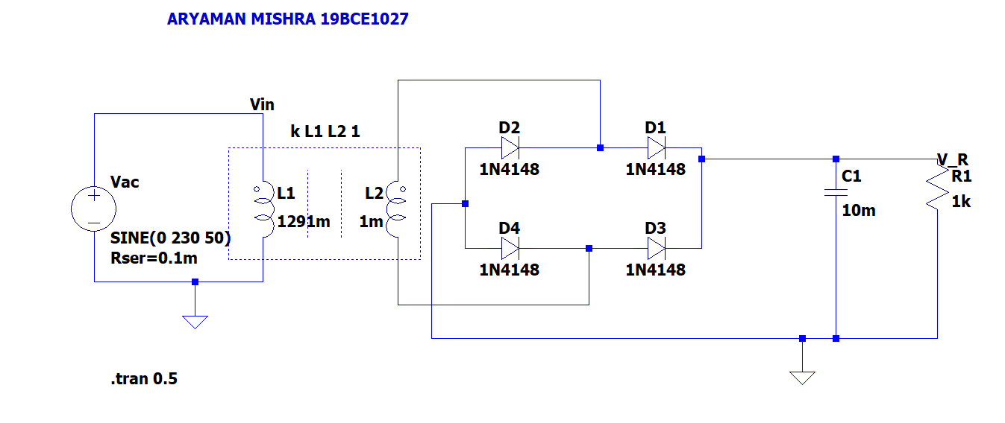

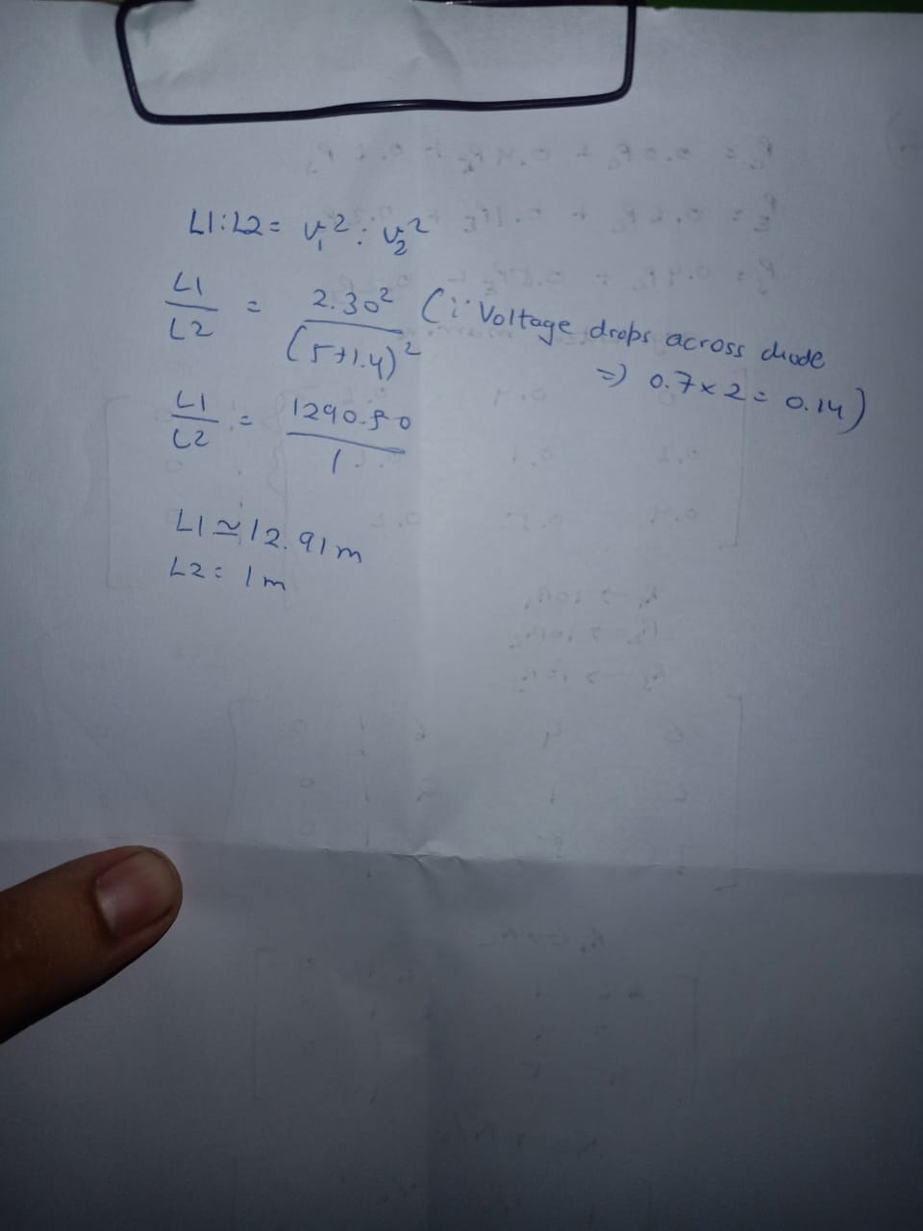

**Conclusion:We designed and simulated the clippers and clampers circuits using LTspice tool. Thus experiment is successfully completed.**